# Testing Documentation

## Project: Dependency Aware Assessment Generator

### Component: New user Registration

#### Normal user Registration

Working in light and dark mode, Displays an alert on the top of the screen stating new user registered. However, after an error, the message does not go away after correct user registration.

Possible improvement: Beautify the alert, Fix the label so the message disappears or changes to something appropriate after the person registers successfully.

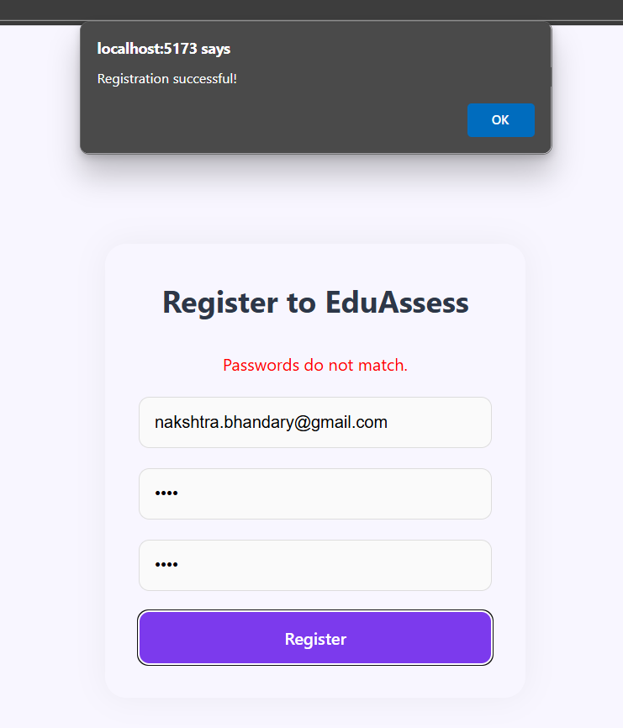

#### Using a mail ID that already exists:

User already exists message is displayed at the top of the component in light and dark mode

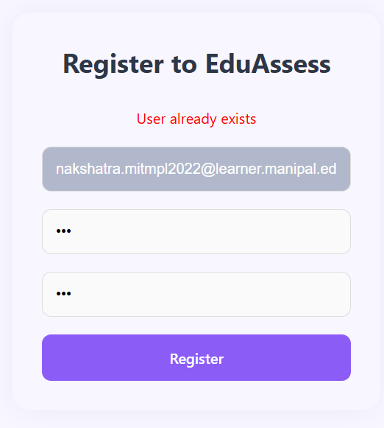

#### If the password does not match

A message is shown stating the password does not match in light and dark mode.

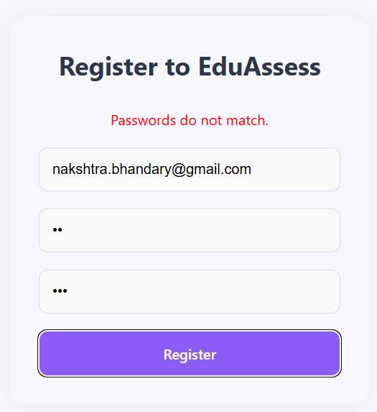

#### Using a mail ID that already exists and password is not the same:

Displays a passwords do not match message, but does not mention the mail ID has been repeated.

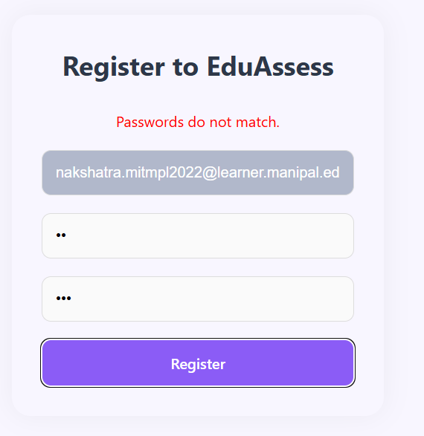

Possible improvement: Mention both issues

#### Other possible improvements

Create a feature for the user to delete their account and profile.

The White colour of the text boxes on the login and registration pages are very bright, would be better to shift it to a cream colour.

### Component: Login

#### Wrong password

Displays an error message invalid credentials

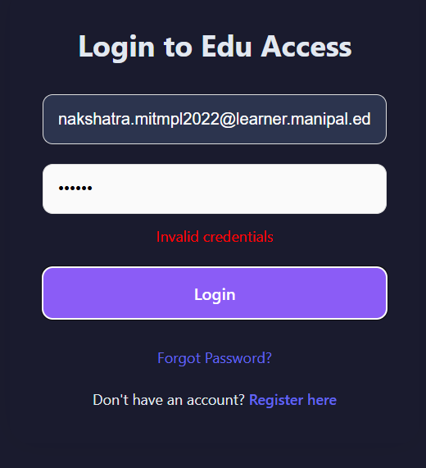

#### Wrong user email

Gives the same error message stating invalid credentials.

#### Correct credentials

Allows login in light mode and dark mode and gives an alert.

Possible improvements: Alert can be beautified.

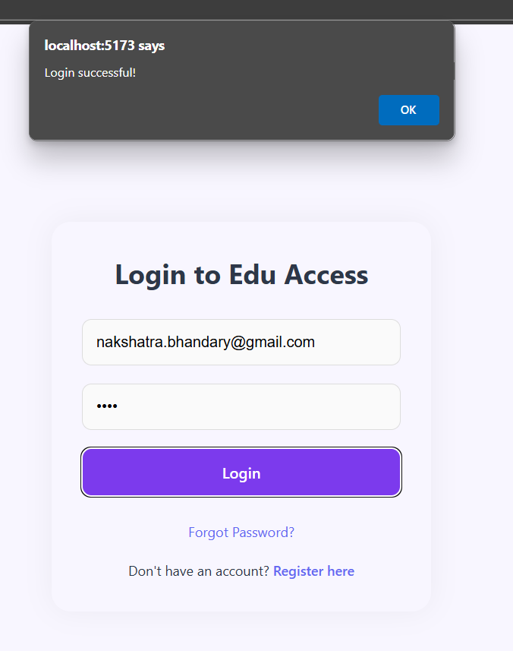

### Component: Logout

#### Logout

When yes is clicked it successfully logs out and prevents users from accessing the dashboard.

Works in light and dark modes.

#### Possible issue

If we go to a new tab and open login, then we can login as another user and the previous already logged in user gets automatically logged out. This needs to be fixed by either preventing someone new from logging in or alerting the other user that they are being logged out. Could be a problem in the future when considering scalability.

### Component: Search for target topic in dropdown

#### Normal search

Works fine, the topics are listed in order of difficulty, not alphabetically based on the search term.

#### Incorrect term

There are no options in the drop down

Possible Improvement: Add a message that says term not found or something user friendly to let them know.

### Component: Listing prerequisites and changing topic

Works well, the change topic clears all previously listed prerequisites and re lists them correctly based on topic chosen.

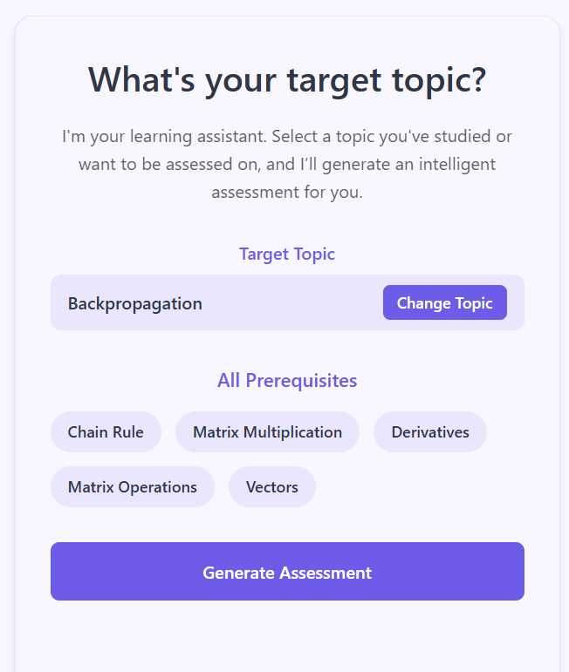

### Component: Generate Assessment

#### When no topic is chosen

The button does not function or display anything.

Possible improvement: Add a user friendly message that says no topic chosen.

#### When a topic is chosen and changed without clicking generate assessment

The questions are displayed based on the latest topic chosen

#### When the topic is changed after clicking generate assessment before clicking submit assessment

Timer resets and new set of questions are displayed.

#### When the topic is changed after clicking generate assessment after clicking submit assessment

Works as expected

#### Possible Improvements

Add more user friendly messages while the questions are being generated if the user is forced to wait for longer than 15-20 seconds

### Component: Quiz

Cannot deselect an option once selected, it can only be changed.

Questions can be selected and searched. This needs to be disabled

Students can access chatbot during the quiz, this should be disabled.

Moreover, the questions themselves are sometimes displayed with words in two asterisks (**not**) which needs to be correctly formatted.

Possible improvement: If there are no prerequisites we do not need to generate a quiz, we can directly say user is qualified to study the topic

### Component: Submit assessment, try again, download report

All work as expected.

### Component: Timer

Generates time correctly based on number of questions

Counts down at the correct pace.

When the timer hits zero: The assessment is automatically submitted. Try Again works. When the automatic submit happens when the timer becomes 0 on the new assessment however it shows the old assessment report, not the new one.

Then after retrying the submit button does not work.

The submit button works after generating a new quiz after the timer has run down.

### Component: Chabot

The answers are unnecessarily long and do not always answers the question asked appropriately.

It answers questions which are out of bounds like the answers to questions given in the quiz, ie ML concepts.

It works on the dashboard page and login page.

The history of the chatbot does not transfer between pages. It starts fresh after logging in.

The chatbot is not giving the correct list of prerequisites based on out json file. However the list of topics mentioned are correct.

Chatbot is not available on the registration page. It needs to be added for improved UI/UX.

### Component: Forgot Password

When we put in the invalid code before putting in the valid one the message does not change. The message never changes. It needs to change to code verified or some other user friendly message like that

The UI can also be improved, currently it does not suit the page and the modal is in an awkward position.

Also, the mail usually goes to spam. In outlook it gets quarantined. So when it goes into production a legitimate mail ID needs to be used. The mail ID used also needs to be a gmail ID.

May need to add an admin panel to be allowed to change the mail ID associated with the forgot password mail

Future scope involves adding phone number verification.

### Other

It works for multiple users simultaneously as checked using two browsers.

Low latency while generating questions, time taken is under the required threshold specified in the SRS.

We need to change the heading of the page, it can’t remain Vite + React + TS

The requests are sort of cached, so if there is an issue on one browser the wrong questions may be displayed on another browed. Needs to be kept in mind when we consider scalability.

Submit assessment works correctly for multiple repeated assignments. It is only when we do automatic submission using timers that we break the submit button. Till then it works.